CO2 AT2-EXPERIMENTS

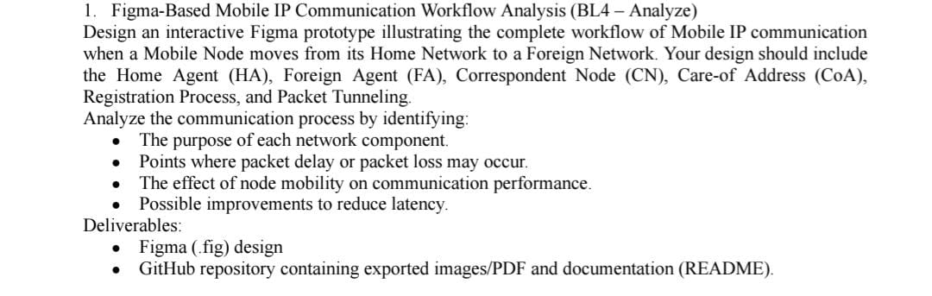
https://www.figma.com/design/NsKZHsARizlrWjneMVRNtQ/Mobile-IP-Prototype?node-id=1-3&t=1ANeFMqtaZPcKYfl-1
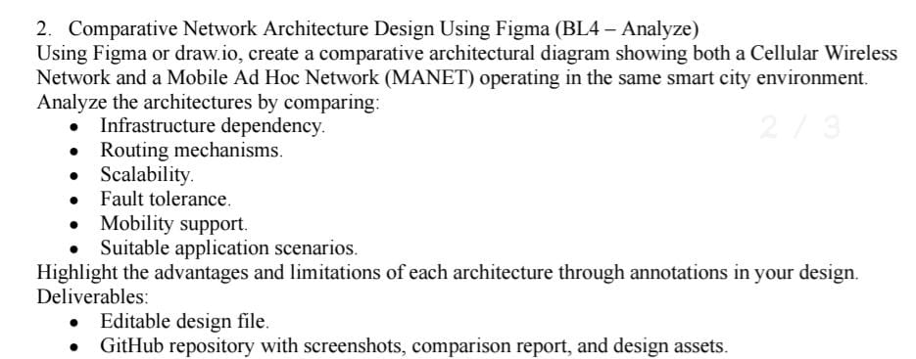
https://www.figma.com/design/fOOBDM7BCCJP5PZQl0rYOb/Comparative-Architechture?node-id=0-1&t=oinOvm365YiWGY40-1
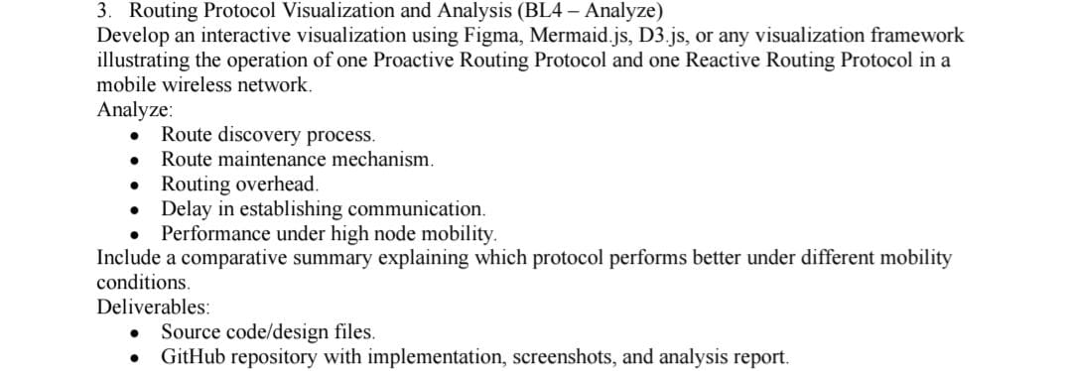
https://www.figma.com/design/wAG2meeTIpVx842lC0MKVF/Routing-Protocol-Visualization-DSDV-vs-AODV?node-id=0-1&t=KeWFnZSFaYxzegmi-1
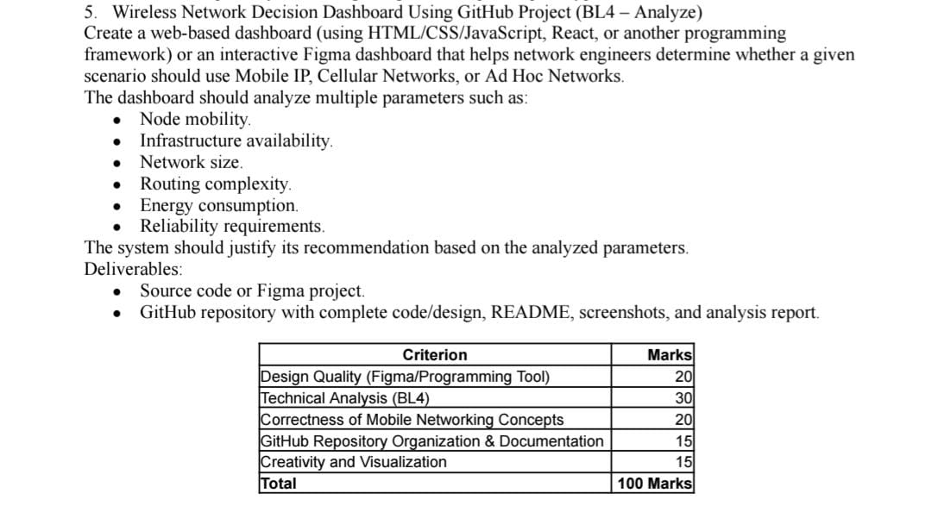
https://www.figma.com/design/Io33UcvwoSu70ZuYASTM8z/Wireless-Network-Decision-Dashboard?node-id=0-1&t=HynZKiCXVJN4GrHI-1

